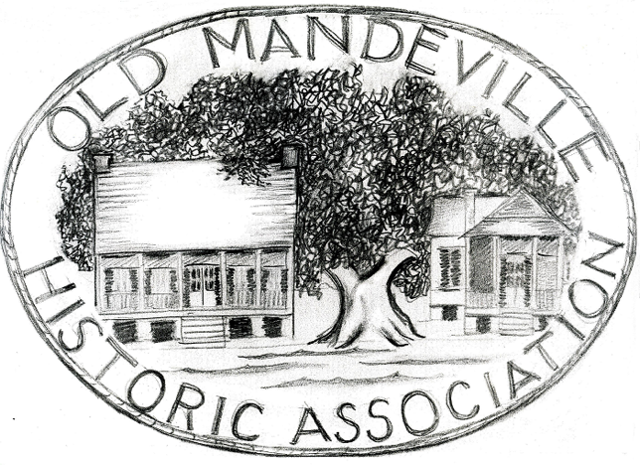

Old Mandeville Historic Association
Historic Structure Program and Site Plaque Application
The intent of this program is to promote appreciation of our cultural and
architectural heritage through identification of historic structures, resulting is an
accurate guide to our past through our surviving buildings.
The historic site plaque is the 'on the street' visual component and is at
the very heart of the program making history evident and accessible. A plaque is
not required to be included in the program.
Date

Name of applicant, _________________________________________________

Address of applicant. _________________________________________________

Phone_______________ email____________
Information on historic structure:
Address of building __
Built or circa date of construction (required for plaque) _
Name selection, based on historical data, to be included on plaque (not required)
____________________________________________________________
Architect or builder (if known)

Significant persons or original owner associated with property
Page 2
Significant events associated with property (If known)
Significant architectural details
Please include copies of documents supporting the details above and photograph
of structure. (Required for registry and site plaque)
For assistance researching your property's unique history, OMHA requires a $50.00 deposit to begin this process. A deposit is not required if such research is complete.
To order a site plaque, please submit a check in the amount of $175 payable to The Old Mandeville Historic Association (OMHA), 605 Carroll Street, Mandeville
Signature of applicant. _
“There may have been a time when preservation was about saving an old
building here and there, but those times are gone. Preservation is the business of
saving communities and the values they embody."
Richard Moe, President
National Trust for Historic Preservation

Refer any questions to:

Nancy Clark
420 Carroll Street
rylaur@bellsouth.net

985 630 3178

